**DevOps Task**

# ***For GUVI***

**Created by: Mithul Sudharsan R**

**Qualification: BE (computer science and engineering)**

**Date: 13/06/23**

**Index:**

* Scope
* Technology Used
* Output results

**Scope:**

**The scope of this procedural document is to**

1. Create a small web application to display “Hello GUVI GEEK”.

2. Push this application to a specific folder of the given GitHub repository.

3. Create a job in Jenkins and make a build this application.

4. On Every Commit, It has to Build a pipeline of the Application.

5. If needed Use Pipeline as a Code, for Building the entire pipeline.

6. Using Jenkins and Docker Plugin, create an Image of the developed web application.

7. Push the Image Finally to the Docker Hub and send the URL image of the Docker.

**Technology used:**

* **Amazon Web Services (AWS – EC2)**
* **Shell scripting**
* GIT
* Jenkins
* Docker Hub

**output results**

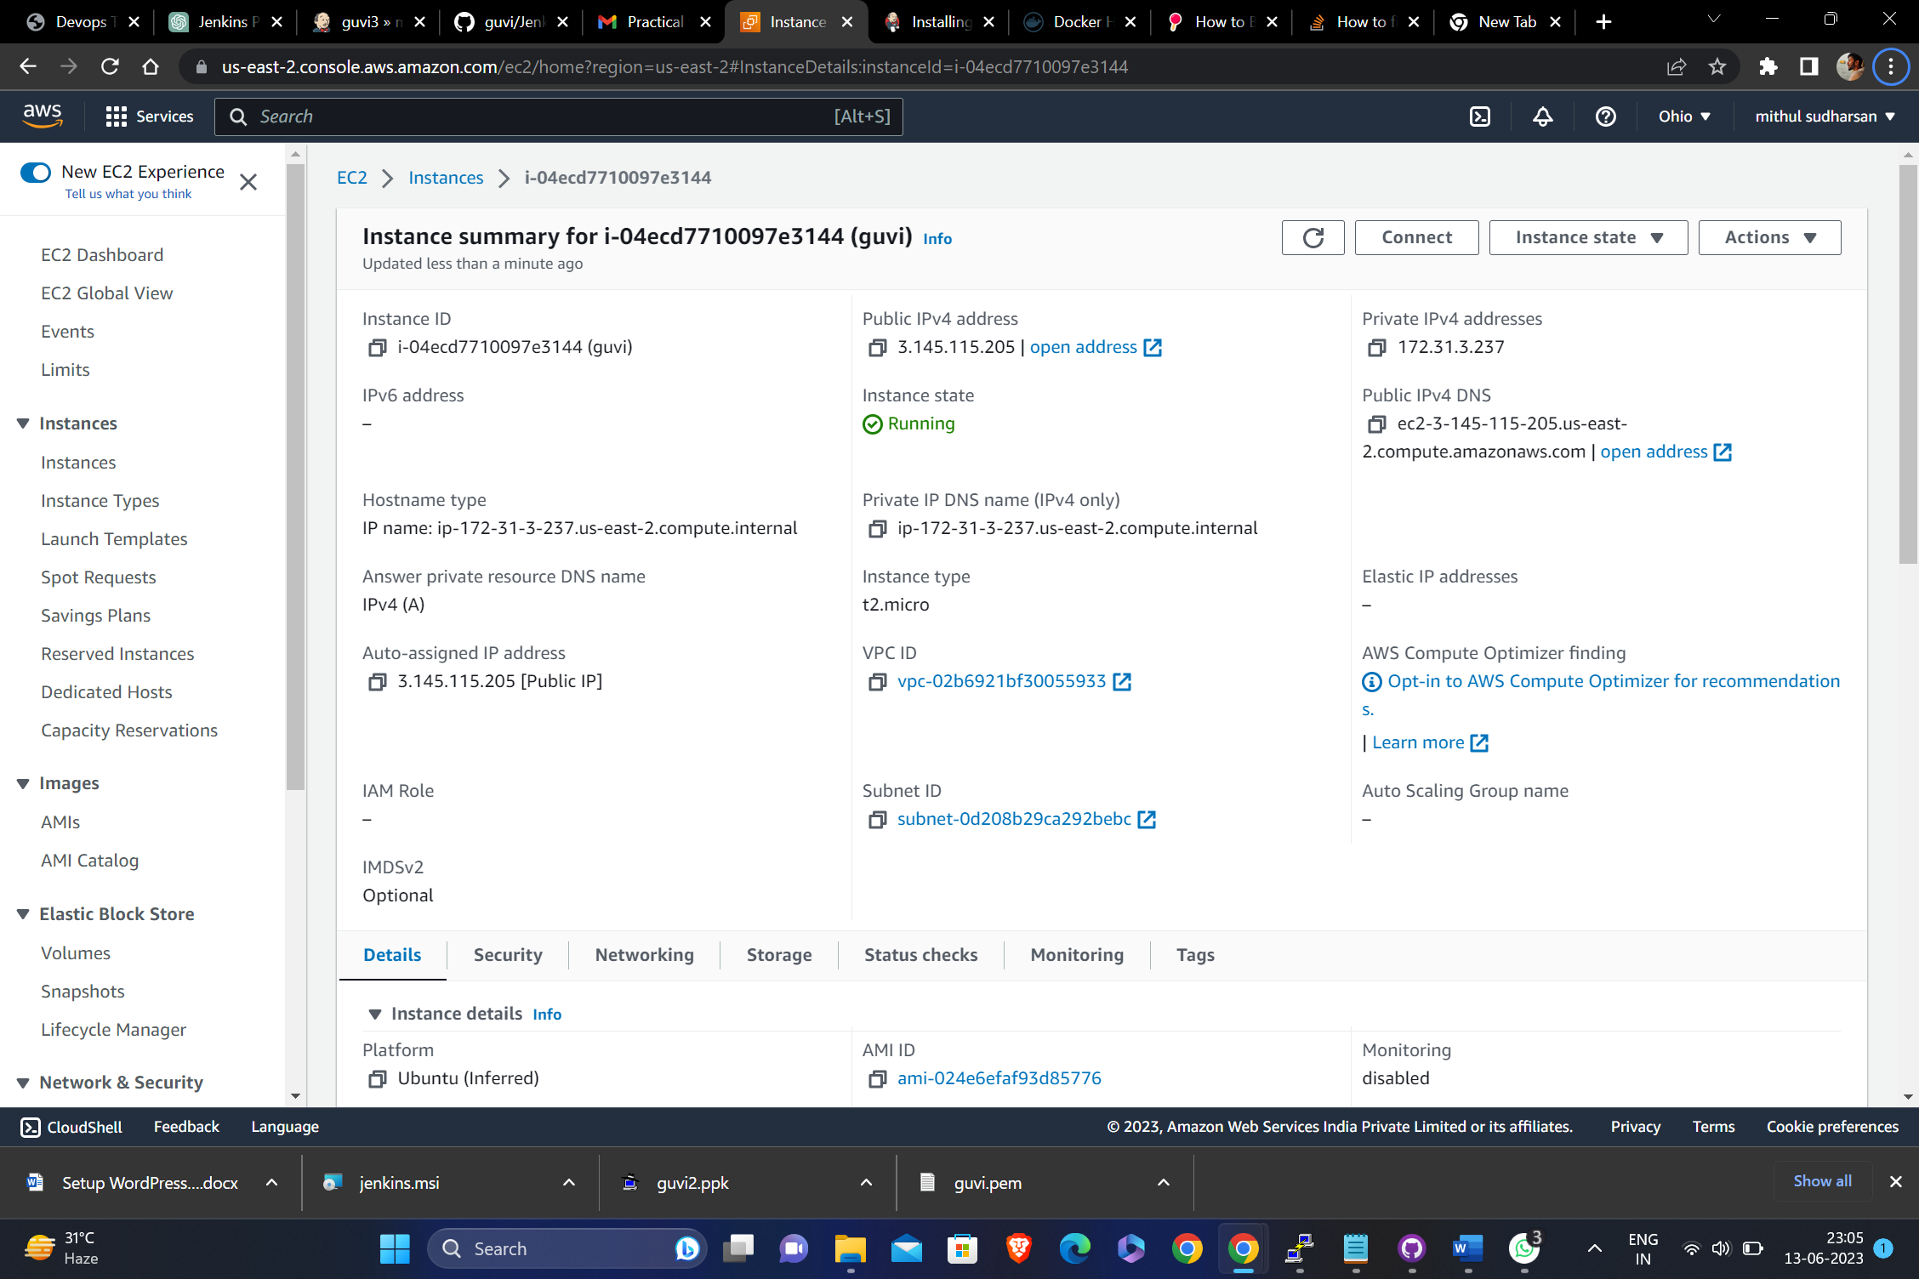

**EC2 instance created**

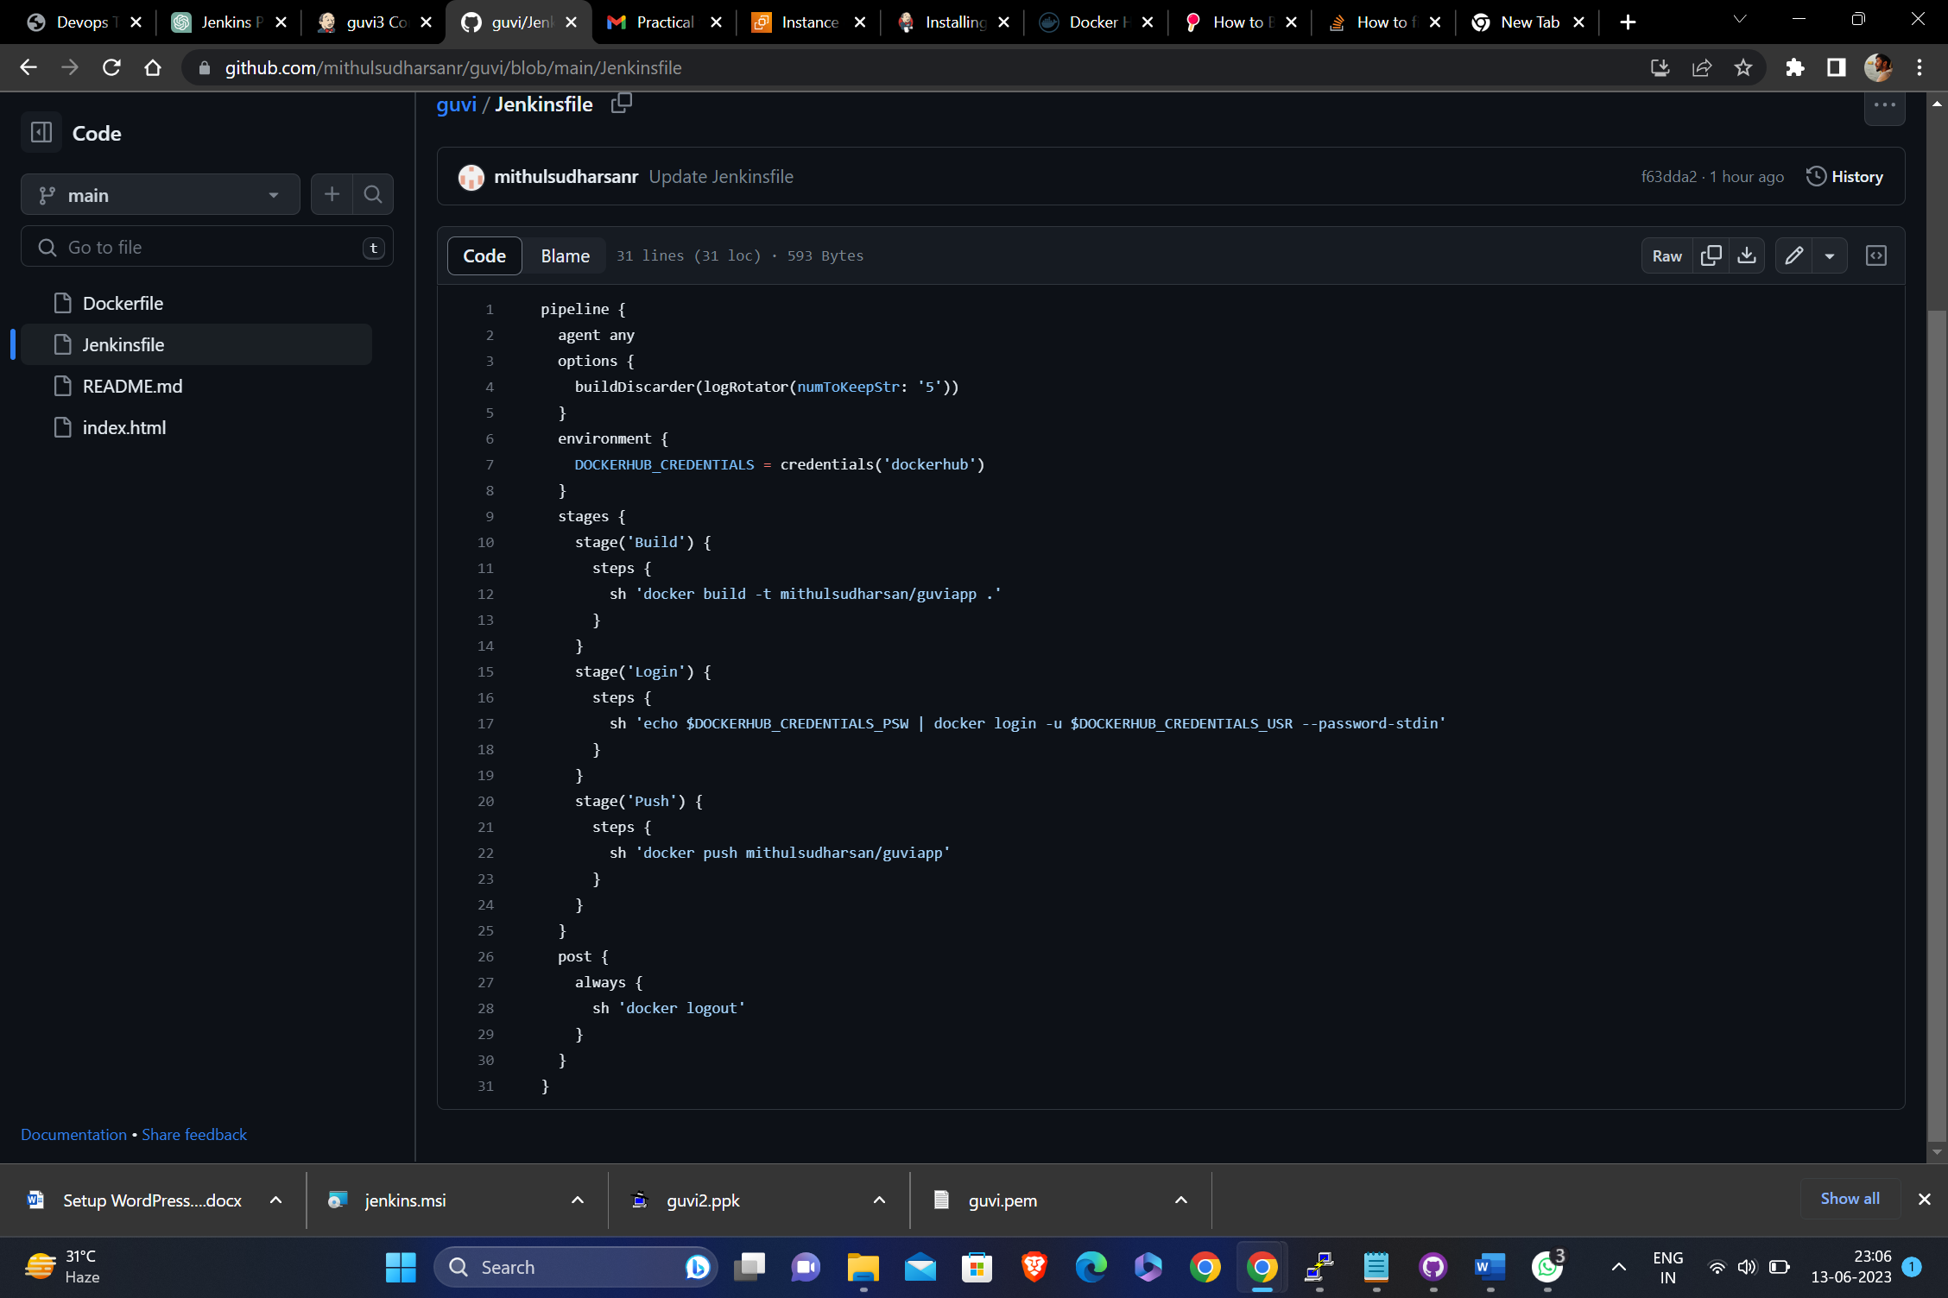

**Pipeline code**

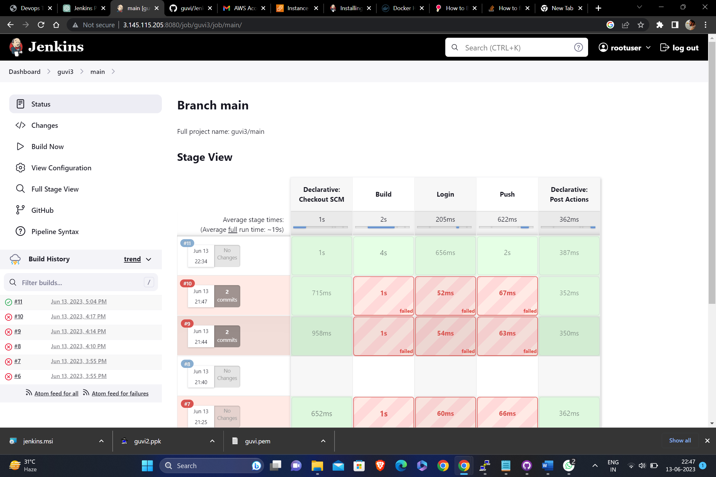

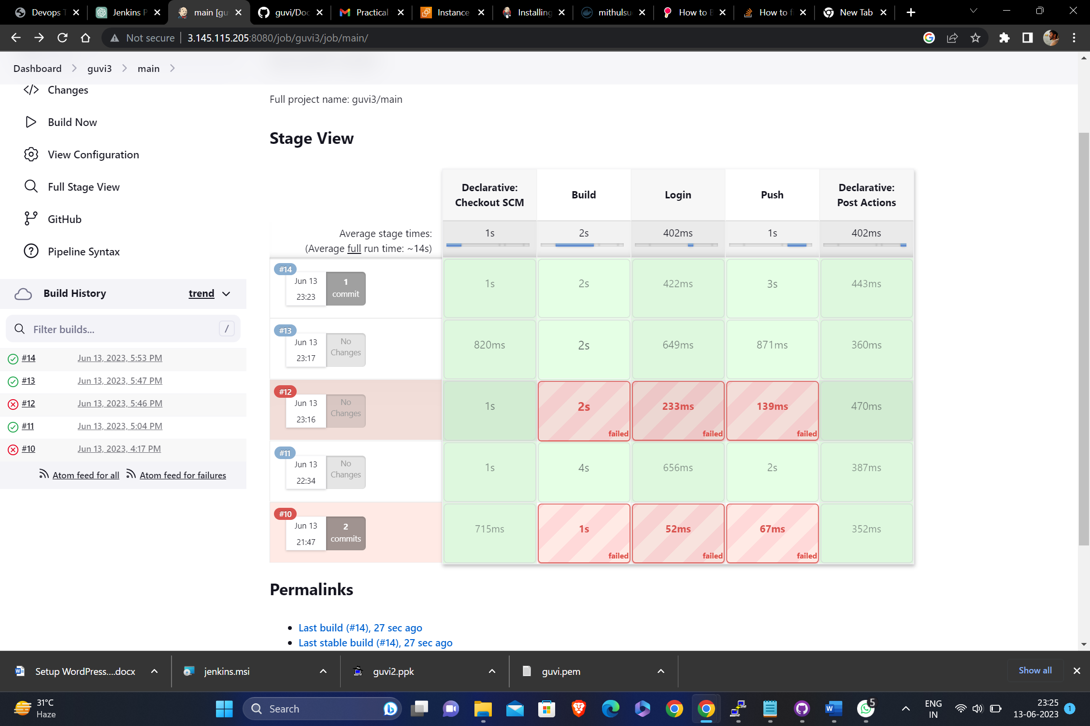

**CICD deployment results**

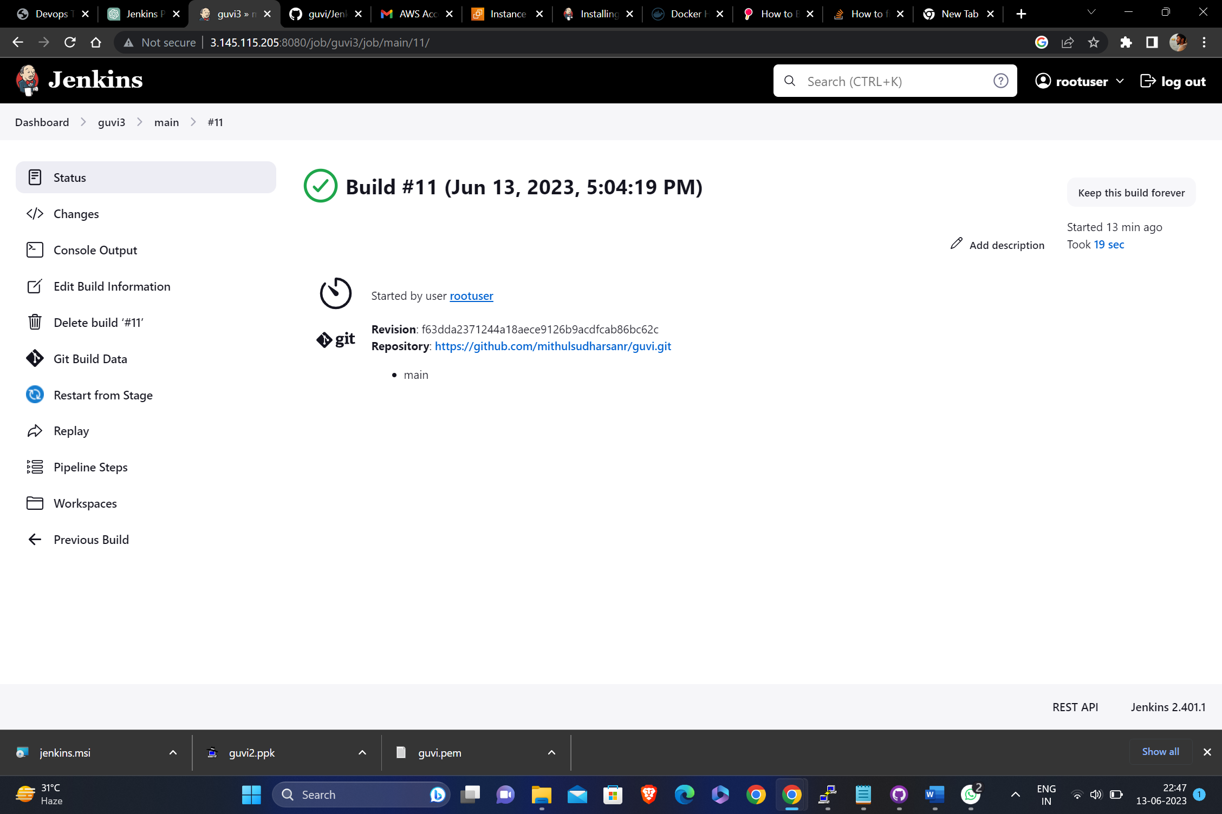

**CICD deployment results**

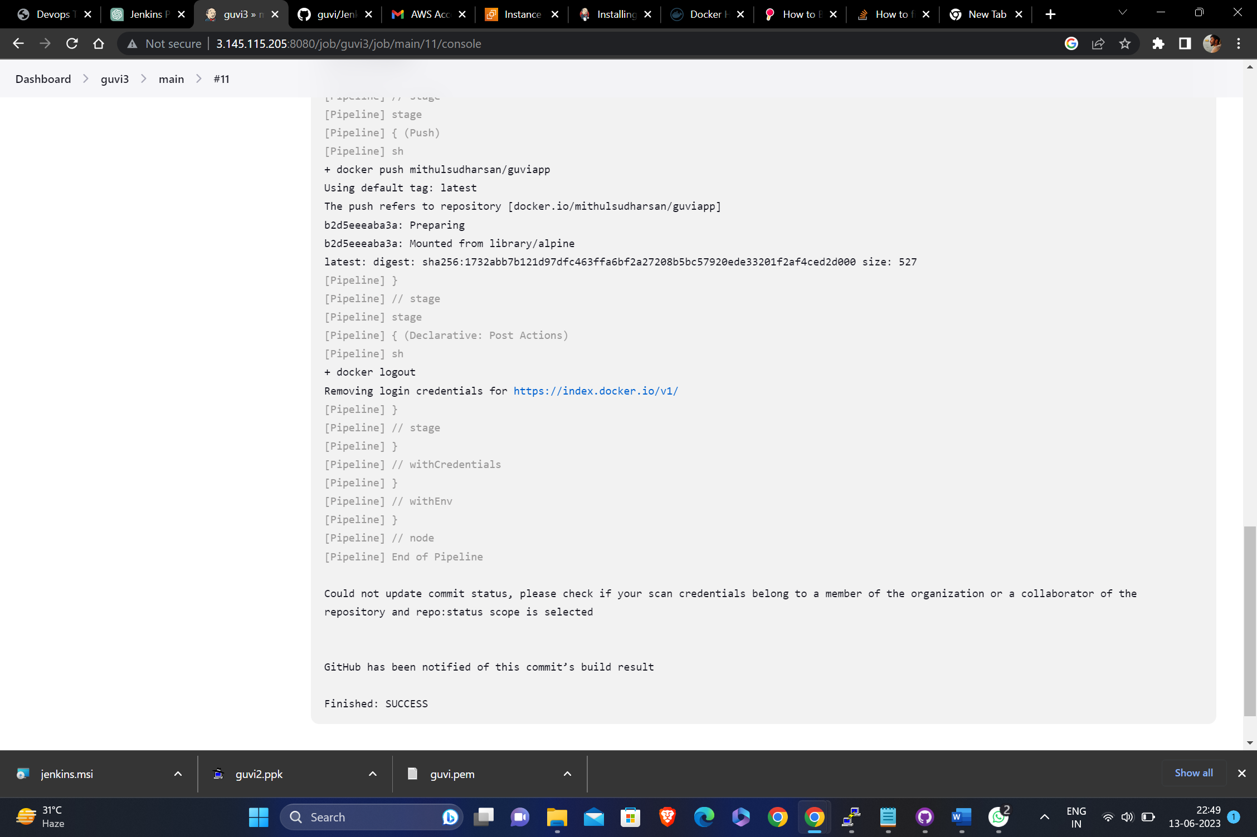

**CICD deployment results successful**

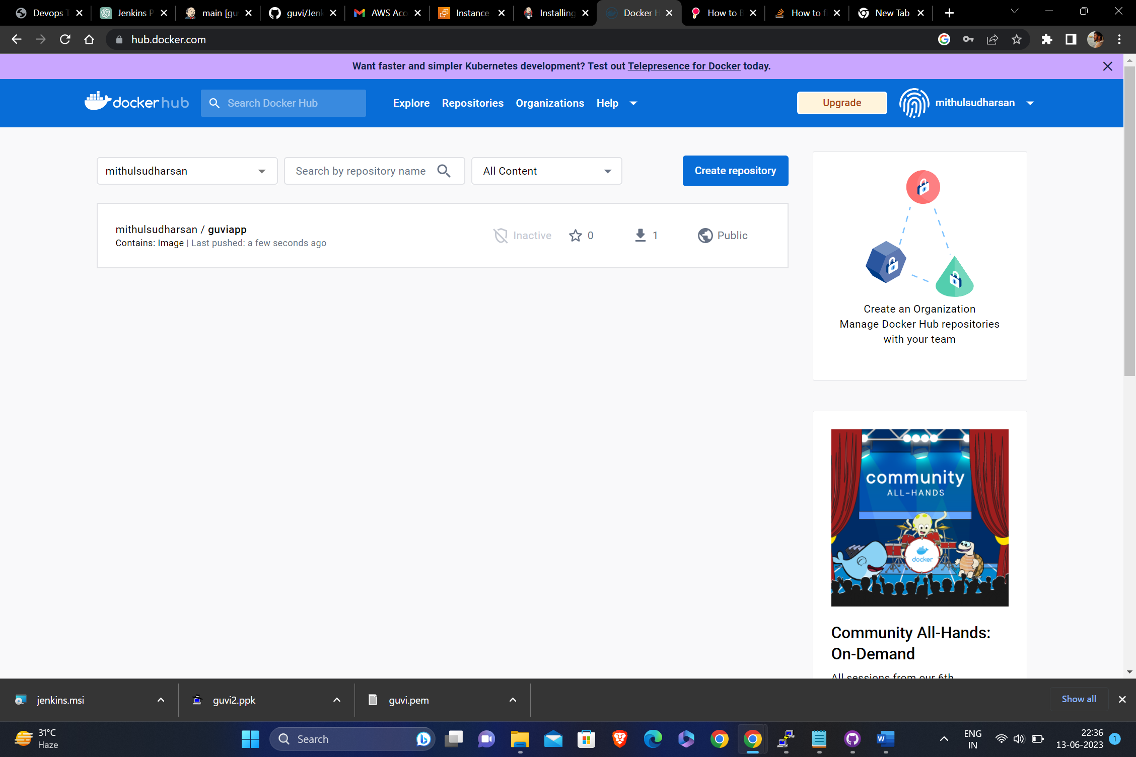

**Docker hub image after getting pushed**